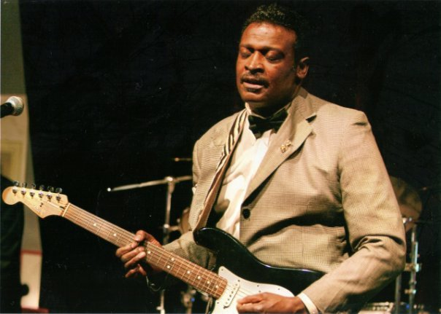

Call Sidney 951-525-9537 or Robin Boyd 224-733-4172

Kit

Custom design your Musical Event

# Visit us at: jjjjjj[www.jadababeentertainment.com](http://www.jadababeentertainment.com)

# 

## Sidney’s one man or full Band.

Prices Varies with custom program, we provide the very best in entertainment, for private parties, corporate events and holiday celebrations.

Sidney’s Soirees

San Jacinto CA.